8.Experiment: User Management & RBAC in Zoho Creator
Aim :
To configure granular User Management and Role-Based Access Control (RBAC) within a Zoho Creator application to secure modules, restrict data visibility, and assign designated operational roles.

Workflow:
Role-Based Access Control restricts system access based on the organizational role of a user. In this lab, we configure an enterprise application in Zoho Creator featuring three distinct user tiers:
Role Name | Assigned Permissions | Data Access Scope
Administrator | Full Create, Read, Update, Delete (CRUD) | All records across organization
Manager | Read, Update, Approve Records | Assigned Region / Department records
Standard Employee | Create & Read own submissions | Only self-created records

Procedure:
- Access Developer Mode: Log into Zoho Creator, open your target application, and navigate to the Settings tab in the left-hand builder menu.
- Configure Users & Roles: Click on Users & Permissions under the Users section. Select the Roles sub-tab and create custom roles (e.g., Manager, Employee) alongside the default Administrator role. Establish hierarchy reporting lines if required.
- Define Profiles & Permissions: Navigate to Profiles to fine-tune module-level permissions (Form creation, Report viewing, Edit/Delete rights).

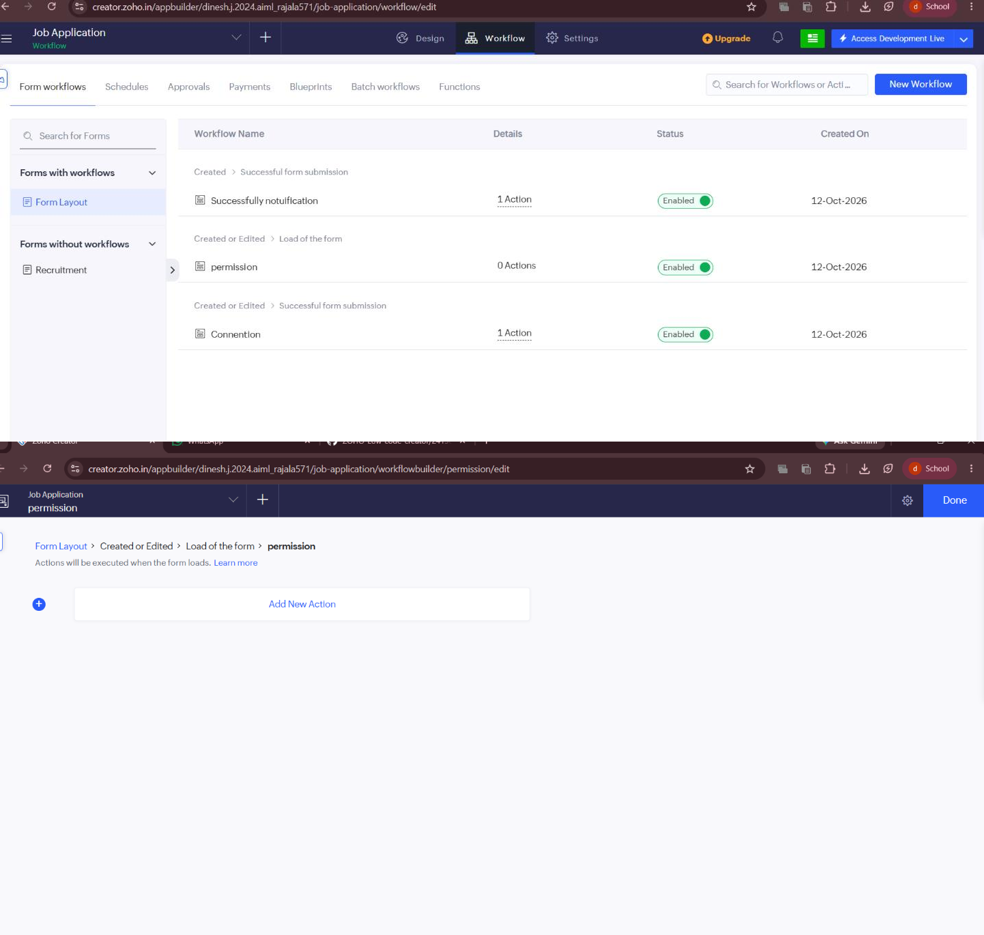
Screenshots:

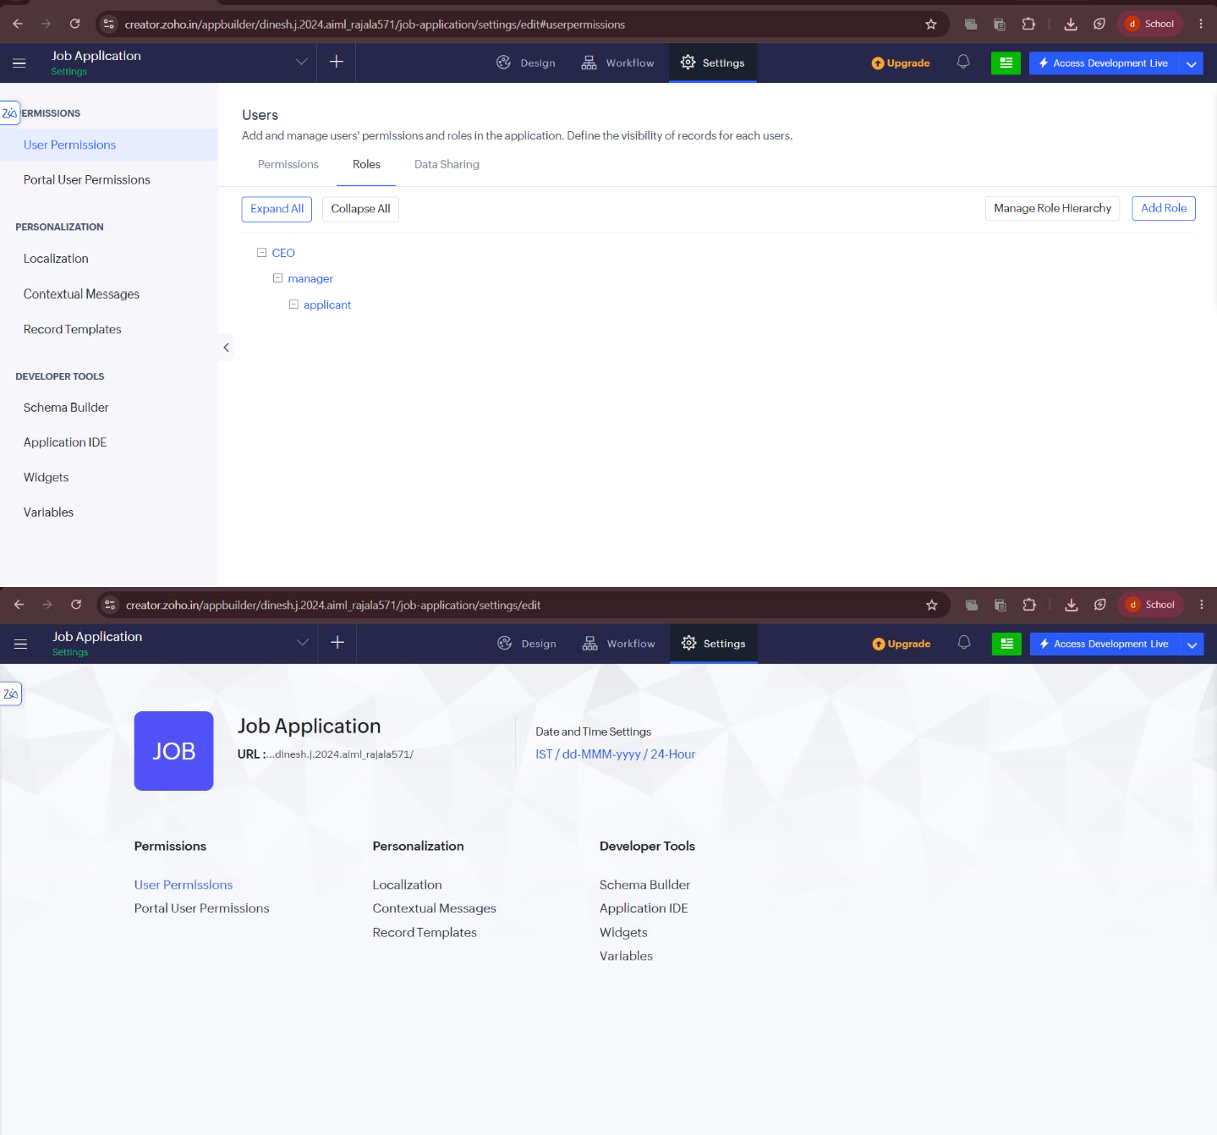

Result:
User management and RBAC rules were successfully configured and tested in Zoho Creator, ensuring robust application security, data isolation, and structured multi-user workflow execution.

